Official Year Book Programme Order Form Season 2012 to 2013

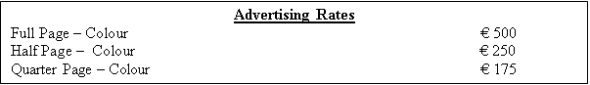

Company name: ___________________________________________________

Company address: ___________________________________________________

___________________________________________________

Your name: ___________________________________________________

Position in company: ___________________________________________________

Please Tick as appropriate: Full Page Colour Half Page Colour
Quarter Page

Date: ____________ Total Cost € ______________

This order is not subject to cancellation. No verbal agreement or otherwise will be accepted unless noted on this order. Advertisement artwork must be supplied in good time for publication, preferably by e-mail to info@nuimbarnhall.com or on CD.

Signed: ____________________________________

** We sincerely thank you for your kind support **

Office Use Only:

Here To Follow Repeat

Paid in Full: Yes  No 

Received by (Print Name) : ____________________ (signature): ____________________

